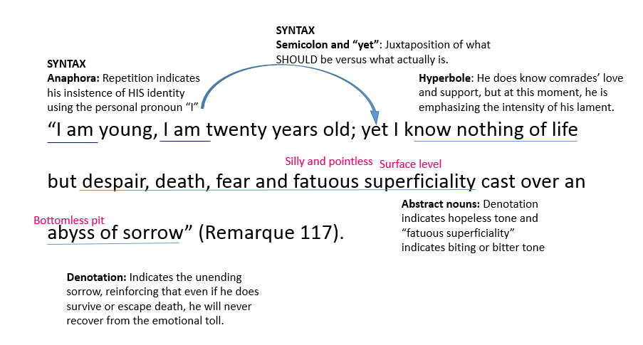

Throughout the novel, Remarque often comments on the injustice of war through Paul’s introspective lamentations. As Paul witnesses the heartbreaking and often sickening injuries of his fellow soldiers during his recovery in the hospital, he mourns the loss of his youth. He thinks, “I am young, I am twenty years old; yet I know nothing of life but despair, death, fear, and fatuous superficiality cast over an abyss of sorrow” (Remarque 117). Even in the minutia of Remarque’s diction and syntax, he emphasizes the devastating effects of war on a man’s psyche. The repetition of “I am” conveys Paul’s insistence to himself of his identity. However, the juxtaposition of this anaphora to the devastating realization following “yet” contrasts what should be true for Paul versus what is-- that he should have his entire life ahead of him, but his experiences in war have taken his boyhood. Remarque’s use of hyperbole when Paul thinks that he “[knows] nothing of life but despair” magnifies his grief, and the following word choice of “death, fear, and fatuous superficiality” serve to reinforce the hopeless and bitter tone of the novel. Finally, the certainty of Paul’s bottomless “abyss of sorrow” conveys Remarque’s ultimate warning against the everlasting impact that war has on those who experience it firsthand. Paul’s internal conflict proves that even those who physically survive the brutal conflict will never be able to recover from the emotional toll of warfare.

Get 3 highlighters. Key the paragraph with the following steps.

- Highlighter #1: Context
  - Remember this should be enough to help the reader understand,
but should NOT be sentences of plot summary!
- Put a “D” above the device when named
- Box out the author’s name
- Highlighter #2: Analysis of device
- Highlighter #3: Connection to theme/work as a whole
- Underline THEME

